**Part 1: Configure the FTP Server**

**Step 1: Activate the FTP Service.**

a.     Click the **Metropolis Bank HQ** and then click the **FTP/Web**server.

b.    Click the **Services** tab and then click **FTP**.

c.     Turn on the FTP service using the radial button at the top.

**Step 2: Allow users’ access to the FTP server.**

a.     Create user account names of **bob**, **mary**, and **mike**, each with the password of **cisco123**.

b.    Each user account should have full permissions (RWDNL) on the FTP/Web server.

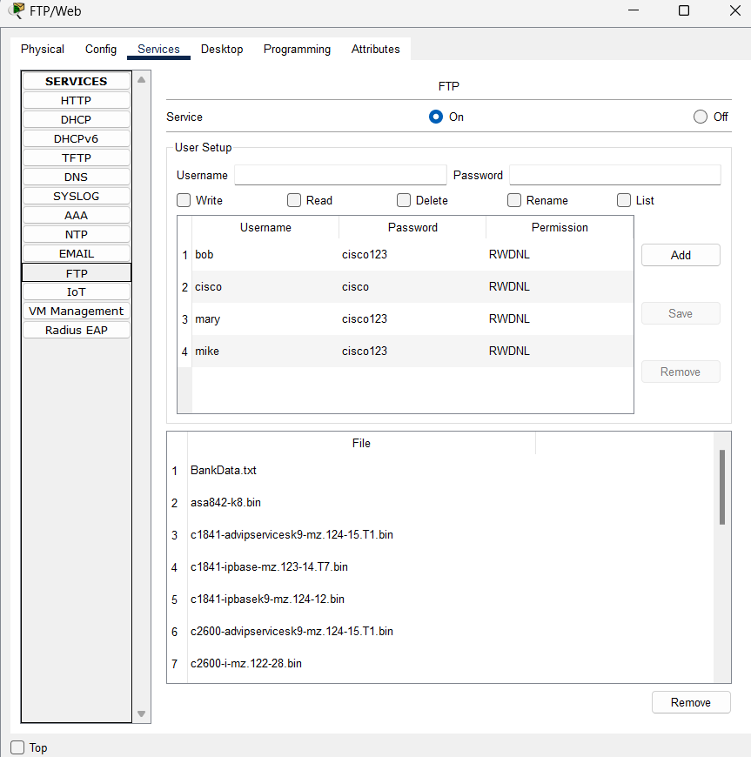

**Part 2: Configure the Web Server**

**Step 1: Activate the HTTP Service.**

a.     Within the **Metropolis Bank HQ**, click the **FTP/Web**server.

b.    Click the **Services** tab and then click **HTTP**.

c.     Turn on both the HTTP and HTTPS services using the radial buttons at the top.

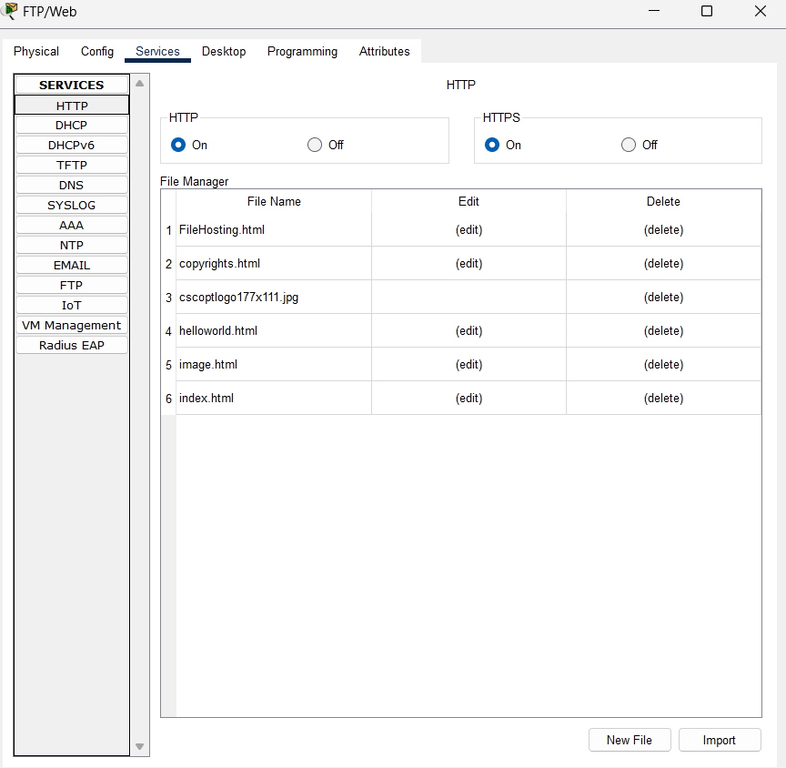

**Step 2: Verify the HTTP Service.**

a.     Click the PC named Sally, and click the **Desktop** tab.

b.    Click the **Web Browser**. Browse to the website **www.cisco.corp**.

c.     Within the Web Browser, browse to the IP **10.44.1.254**.

Why would a user be able to browse to an IP address but not a FQDN?

The web browser does not know IP address without DNS to translate the domain name to the IP address.

**Part 3: Configure the DNS Server**

**Step 1: Activate the DNS Service.**

a.     Within the **Metropolis Bank HQ**, click the **Email/DNS**server.

b.    Click the **Services** tab and then click **DNS**.

c.     Turn on the DNS service using the radial button at the top.

**Step 2: Create the DNS A records.**

a.     Create the **A** record **email.cisco.corp** with IP address **10.44.1.253**. Click **Add** to save the record.

b.    Create the **A** record **www.cisco.corp**with IP address **10.44.1.254**. Click **Add** to save the record.

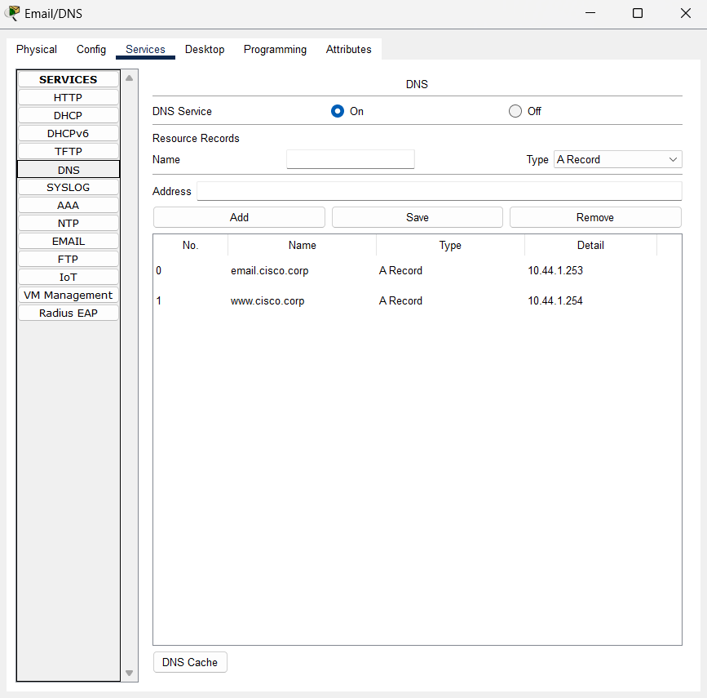

**Step 3: Verify the DNS Service.**

a.     Click the PC named Sally, and click the **Desktop** tab.

b.    Click the **Web Browser**. Browse to the website **www.cisco.corp**.

Why is the user able to browse to an FQDN?

The DNS server translated the domain name to the associated IP address so the web browser can understand it.

**Part 4: Configure the Email Server**

**Step 1: Activate the Email Services.**

a.     Within the **Metropolis Bank HQ**, click the **Email/DNS**server.

b.    Click the **Services** tab and then click on **EMAIL**.

c.     Turn on both the SMTP and POP3 services using the radial buttons at the top.

**Step 2: Create Email accounts for users.**

a.     Create the domain name of **cisco.corp**.

b.    Create user account names of **phil**, **sally**, **bob**, **dave**, **mary**, **tim** and **mike,**each with the password of **cisco123**.

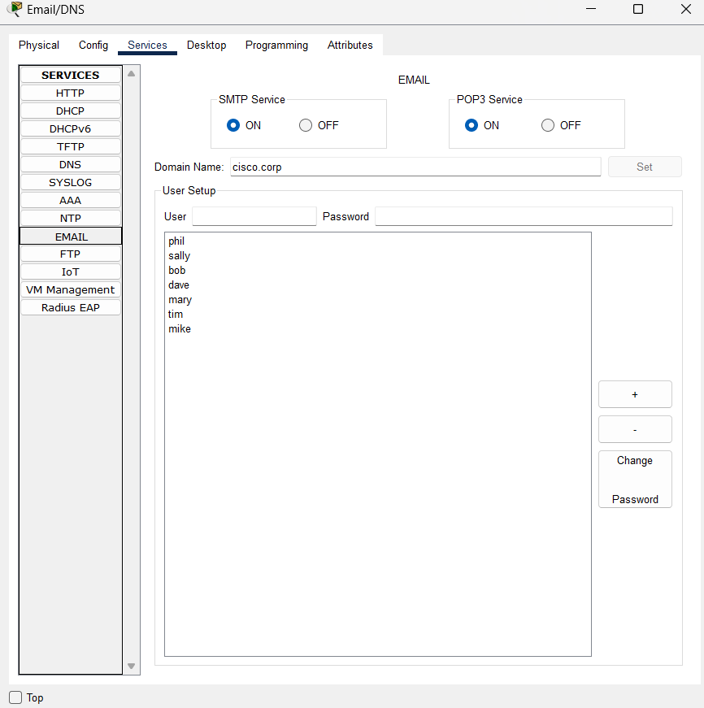

**Step 3: Configure user Email clients.**

a.     Click the PC named **Sally**, and click the **Desktop** tab.

b.    Click **Email**and enter the following information:

Name: **Sally**

Email Address:**sally@cisco.corp**

Incoming & Outgoing Email Server(s): **email.cisco.corp**

Username: **sally**

Password: **cisco123**

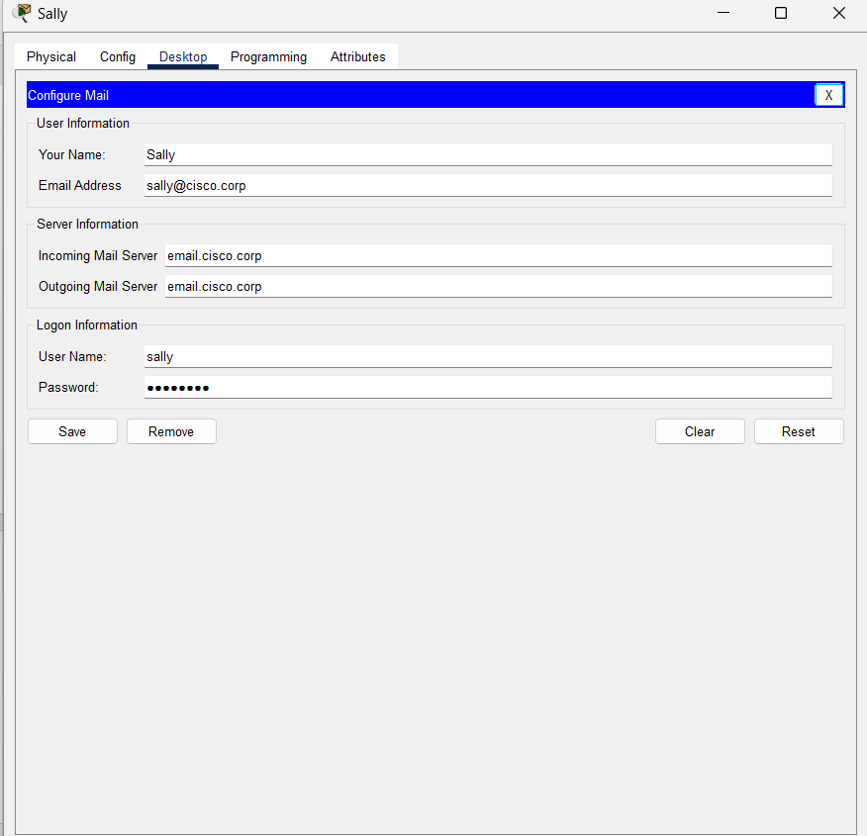

c.     Repeat Step **3b** on the PC named **Bob** but replace the name **sally** with **bob** as needed.

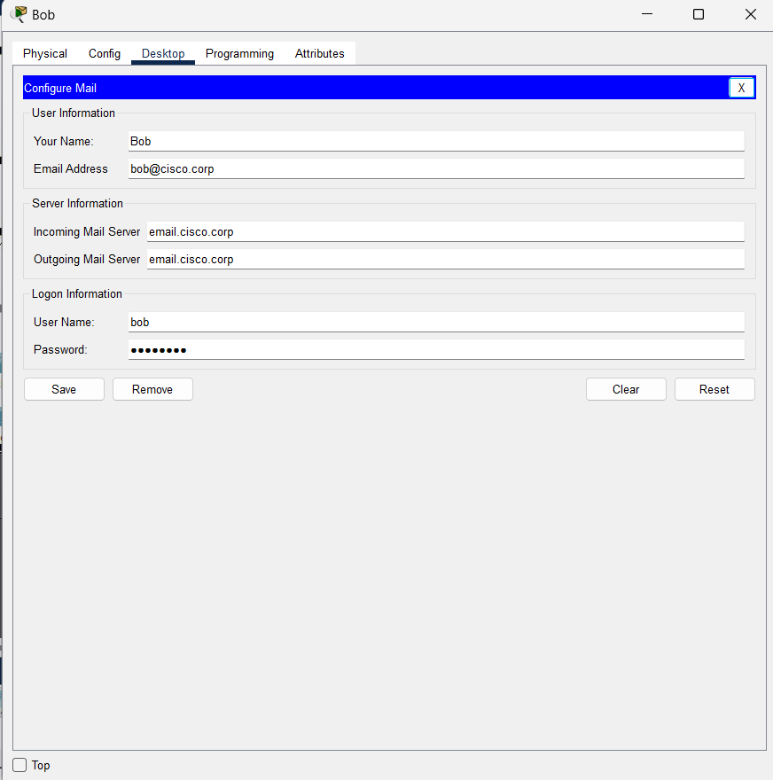

Why does the Email service require both SMTP and POP3 to be activated?

SMTP is the protocol responsible for sending emails between servers, and POP is a protocol used by local email clients to retrieve emails from a server.

**Part 5: Configure the NTP Server**

**Step 1: Activate the NTP Service.**

a.     Within the **Metropolis Bank HQ**, click the **NTP/AAA**server.

b.    Click the **Services** tab and then click **NTP**.

c.     Turn on the NTP service using the radial button at the top.

**Step 2: Secure the NTP Service.**

a.     Enable the NTP authentication feature using the radial button.

b.    Configure **Key 1** with a password of **cisco123**.

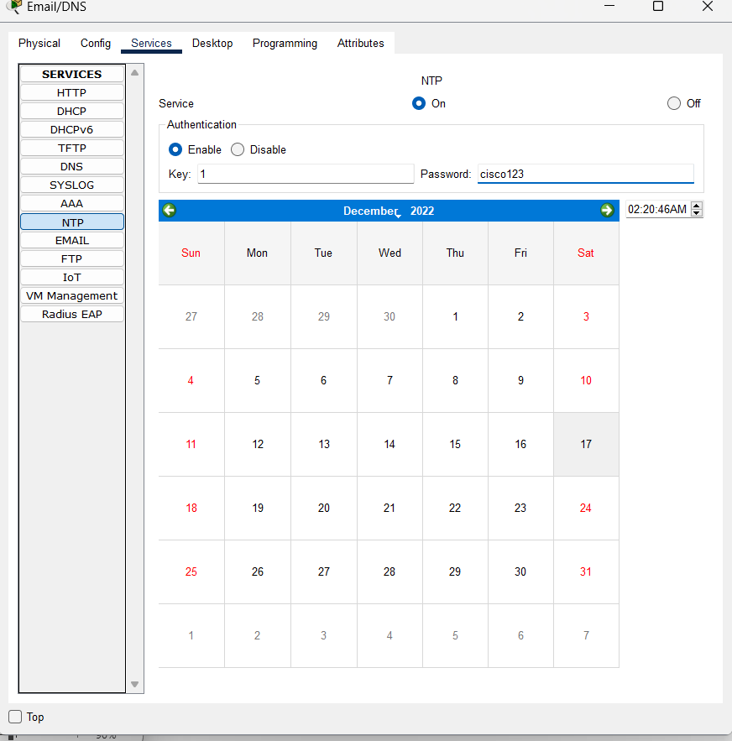

**Part 6: Configure the AAA Server**

**Step 1: Activate the AAA Service.**

a.     Within the **Metropolis Bank HQ**, click the **NTP/AAA**server.

b.    Click the **Services** tab and then click **AAA**.

c.     Turn on the AAA service using the radial button at the top.

**Step 2: Configure the AAA Network Configuration.**

a.     Configure the Client Name **HQ_Router** with the Client IP **10.44.1.1**with a secret of **cisco123**. Click **Add** to save the client information.

b.    Configure the AAA user account of **admin** with a password of **cisco123**. Click **Add** to save the user information.

